

KLE SOCIETY’S LAW COLLEGE, BENGALURU
(Constituent College of KLE Technological University, Hubballi)

In-Semester Assessment
Topic:
REPORT ON TORT LAW DISPUTE NEGLIGENCE
Student Registration Number: | 0 | 3 | F | L | 2 | 5 | B | L | L | 0 | 2 | 5
Programme: | 1st LLB
Semester: | 1
Section: | A
Course Name (Subject): | Law of Tort
Course Code: | 21LLLC103

- INTRODUCTION
Tort = A civil wrong (other than breach of contract or trust) that causes harm or injury to another person, for which the law provides a remedy in the form of damages (compensation).
Negligence is one of the most important branches of tort law.
According to Winfield and Jolowicz “Negligence is the breach of a legal duty to take care which results in damage, undesired by the defendant to the plaintiff.”
In other words, when someone fails to act with the care that a “reasonable person” would exercise in similar circumstances, and that failure causes harm, it amounts to negligence.
Tort law plays an essential role in protecting legal rights by ensuring that individuals who suffer harm due to wrongful acts or negligence receive compensation and justice. It not only safeguards rights relating to personal safety, property, and reputation but also promotes accountability and responsible behaviour in society. By providing remedies and deterring wrongful conduct, tort law upholds fairness, social justice, and the rule of law, thereby maintaining balance between individual rights and societal interests. Although tort cases can help victims recover the monetary damages, they need to restore their lives, many argue that tort reform is necessary.
The Times of India report dated 30th July 2025 on the case of Umamani Nayak vs TPNODL clearly identifies the nature of the dispute, the tort involved, the authority taking cognizance, as well as the impact and violation of legal rights. The dispute arose out of the electrocution death of Sanatan Nayak caused by a snapped live wire managed by TPNODL. The tort involved was negligence leading to strict liability, since electricity distribution is considered a hazardous activity. The Orissa High Court took cognizance of the matter and directed the company to pay ₹2 lakh interim compensation with interest. The report also highlights the impact on the victim’s family, the court’s reliance on the principle of strict liability, and the violation of the deceased’s legal right to life and safety, thereby affirming the protective role of tort law.

- IDENTIFICATION OF DISPUTE
Facts of the Case:
Umamani Nayak vs. TP Northern Odisha Distribution Limited(TPNODL)

Parties:
* Petitioner: Umamani Nayak, the wife of the deceased, Sanatan Nayak, along with their three sons.
* Opposite Party: TP Northern Odisha Distribution Limited (TPNODL), the electricity distribution company.

* Specific Dispute: The family of the deceased, Sanatan Nayak, filed a claim for compensation, arguing that his death by electrocution was a direct result of TPNODL's negligence in maintaining a live electric wire.

* Incident Occurred: On July 6, 2007, Sanatan Nayak was electrocuted to death when he came into contact with a snapped, live low-tension (L.T.) electric wire that had fallen into a water puddle near Sergarh, Odisha.

* Background: The deceased, a labourer of 54 years of age, was electrocuted on 06-07-2007 when he unknowingly came in contact with a puddle of water which was charged with electricity because a live L.T. line wire had snapped and had fallen into the puddle of water on the road. Despite being rescued and hospitalised by the villagers, he succumbed to his injuries on the same evening.

Subsequently an FIR was registered, inquest and post-mortem were conducted, and ASI’s final report were submitted, confirming death caused due to electrocution because of snapping of live electric L.T. lines. The petitioners, i.e. the wife and the sons, contended that the death of the deceased was caused due to the negligence of the Distribution Company’s failure to discharge their duty of properly maintaining the L.T. electric wires in Sergarh village, Balasore, despite several complaints and requests by the residents of the village.
The petitioners argued that the deceased being the sole earning member of the family, his death had not only caused emotional pain and agony to them but also grave financial hardship, therefore sought compensation of Rs 2 lakh with 12 per cent interest per annum.

Additionally, it was highlighted by the petitioners that the Distribution Company by admitting their negligence and liability had initially paid a sum of Rs 10,000 to perform last rites of the deceased and had assured them to pay a just and proper compensation later but did not take any steps in this regard, despite receiving a legal notice from the petitioners. They also referred to the OERC (Compensation to Victims of Electrical Accidents) Regulation, 2020 (‘2020 Regulations’), to substantiate their claim.

It revolves around a fatal electrocution incident and the subsequent claim for compensation. The central dispute was initiated by Umamani Nayak and her three sons, seeking financial relief from the power distribution company, TPNODL, following the tragic death of her husband, Sanatan Nayak.

- IDENTIFICATION OF TORT
In the case of Umamani Nayak vs TPNODL, the primary tort involved is negligence, which further extends into the principle of strict liability because of the inherently dangerous nature of electricity. The electricity distribution company, TPNODL, owed a clear duty of care to the general public to ensure that live electric wires were properly maintained and that no situation was created which could endanger life. Electricity is universally recognized as a hazardous and lethal substance, and therefore, the company had a heightened duty to adopt stringent safety measures, regular checks, and prompt repairs in case of faults.

This duty was breached when a live LT wire snapped and fell into a puddle of water on the road, converting it into a deadly trap for any passerby. The hazard remained unattended, and as a result, Sanatan Nayak came in contact with the electrified puddle and was tragically electrocuted. The failure to take preventive or remedial action amounts to gross negligence on the part of the authority. Such an omission is not a mere lapse; it represents a serious dereliction of a statutory and common-law duty imposed on electricity boards.

The breach of duty directly resulted in the violation of a legal right, namely the right to life and safety. Every individual has the right to use public spaces without being exposed to unreasonable dangers. Tort law serves precisely this purpose—protecting individuals from harm caused by the wrongful acts or omissions of others. Here, the deceased’s fundamental right to safety while walking on a public road was infringed.

Apart from negligence, the case also falls squarely under strict liability. In the celebrated English case of Rylands v. Fletcher, it was established that when a person brings a dangerous thing onto their land, and if it escapes and causes harm, liability attaches regardless of negligence. Electricity clearly comes within the scope of such a dangerous thing. This principle was reinforced in the Indian context by M.P. Electricity Board v. Shail Kumari (2002), where the Supreme Court held that electricity boards are liable for deaths caused by live wires, even if negligence is not conclusively proved, because electricity is inherently hazardous and authorities are expected to ensure absolute safety.

Further, in Municipal Corporation of Delhi v. Subhagwanti (1966), where a municipal clock tower collapsed causing fatalities, the Court applied the principle of strict liability, holding the corporation responsible for failing to maintain a structure in its control. Similarly, TPNODL had control over electric lines, and its failure to prevent the hazard makes it absolutely liable.

Thus, liability in this case arises both under negligence (failure to exercise reasonable care) and strict liability (control of a hazardous substance that escaped and caused death). This case underscores how tort law not only provides remedy through compensation but also acts as a mechanism of accountability, ensuring that public authorities entrusted with hazardous utilities maintain the highest standards of safety.

- IDENTIFICATION OF APPROPRIATE AUTHORITY TAKING COGNIZANCE
In the case of Umamani Nayak vs TPNODL, the matter clearly falls within the jurisdiction of the civil courts since it involves a claim for compensation arising out of negligence and strict liability by the electricity distribution company. Under the law of torts in India, civil courts have the authority to adjudicate disputes concerning wrongful death, negligence, and liability of public utility providers. Depending on the pecuniary jurisdiction and territorial location, the case could be instituted before the District Court or directly before the High Court.

The Orissa High Court, as per reports available on SCC Online, has previously dealt with several electricity-related negligence cases, imposing liability on distribution companies for electrocution deaths. Similarly, in this case, the court would be the appropriate forum to examine evidence, determine breach of duty, and award compensation to the victim’s family.

Furthermore, in certain circumstances, the Supreme Court of India has also taken suo motu cognizance of electrocution deaths, especially where larger questions of public safety and accountability of state agencies are involved. For example, in M.P. Electricity Board v. Shail Kumari (2002), the Supreme Court established strict liability principles against electricity authorities, setting a precedent for cases like this one.

The role of regulatory agencies such as the Electricity Regulatory Commission may also be relevant in initiating departmental action against the negligent officers of TPNODL, but the primary cognizance lies with the civil judiciary. Thus, the proper authority for hearing and resolving this tort dispute would be the civil court system, subject to appeal before the High Court and eventually the Supreme Court.

- IMPACT OF THE ISSUE
The tragic incident in Umamani Nayak vs TPNODL has a multi-dimensional impact that extends beyond the individual victim to society at large. From a social perspective, the case highlights the vulnerability of ordinary citizens who depend on public utilities like electricity. People expect safety when walking on public roads, yet when negligence results in electrocution, it shakes public confidence in institutions meant to protect them. The death of Sanatan Nayak not only caused irreparable loss to his family but also generated fear and insecurity within the community regarding the safety of electrical infrastructure.

From a legal standpoint, the case reinforces the principles of negligence and strict liability in tort law. It aligns with earlier judgments such as M.P. Electricity Board v. Shail Kumari (2002), where the Supreme Court held electricity authorities absolutely liable for electrocution deaths, regardless of negligence being proven. Such cases strengthen tort law jurisprudence by ensuring accountability of state agencies and corporate entities. The dispute also emphasizes the role of courts in upholding the right to life and safety under Article 21 of the Constitution.

The economic impact is also significant. Compensation awarded in such cases imposes financial liability on public utility companies, compelling them to adopt stricter safety measures. At the same time, it provides financial relief to victims’ families, though it can never replace the loss of life. Such judgments serve as a deterrent against future negligence by reminding corporations of the heavy costs of non-compliance with safety standards.

On a policy level, the case calls for better regulations, stricter monitoring of power distribution companies, and clear accountability mechanisms for maintenance failures. State governments and electricity regulatory commissions are often prompted to revise guidelines after such incidents, ensuring regular inspection, preventive maintenance, and public safety measures.

The role of media also plays a crucial part in shaping public perception. By reporting incidents of electrocution deaths and negligence, newspapers bring visibility to tort disputes, creating public pressure for accountability and reform. Such coverage ensures that cases like Umamani Nayak’s are not ignored but rather discussed in the public domain.

In a comparative perspective, the case shows why tort law is essential in India. Unlike in the UK or US, where tort law is well-developed, Indian tort jurisprudence is still evolving. Incidents like this highlight the urgent need for strengthening tort law to ensure justice, accountability, and the protection of fundamental rights in a rapidly developing society.

- CONCLUSION
The case of Umamani Nayak vs TPNODL reflects how tort law operates as a bridge between individual rights and institutional accountability. What began as a routine walk to the market turned into a tragedy because of a negligent omission by a public utility company. The snapping of a live wire and its failure to be repaired on time cost a person his life, reminding us that even simple acts of negligence can have irreversible consequences.

This dispute highlights the torts of negligence and strict liability, showing how the law protects ordinary citizens from dangers they did not create. It also emphasizes that duty of care is not optional for corporations and state authorities but a binding responsibility. Courts, by awarding compensation and enforcing accountability, send a strong message that public safety must always come first.

At a broader level, the case reminds us that tort law in India is not just about compensation but also about justice, deterrence, and reform. It pushes us to reflect on how we, as a society, demand better infrastructure, stricter regulations, and greater awareness of rights. Ultimately, the incident stands as a somber lesson that legal awareness and institutional accountability are essential to safeguard the most basic of all rights—the right to life and safety.

- ANNEXURE

THE NEW INDIAN EXPRESS
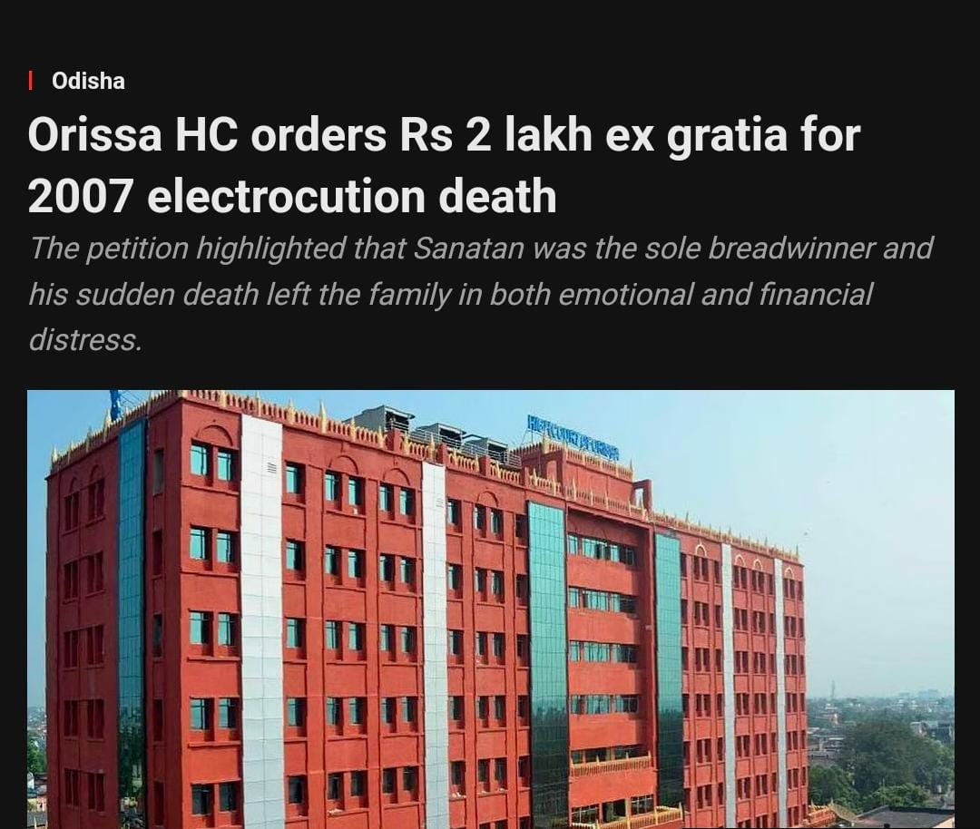

TIMES OF INDIA
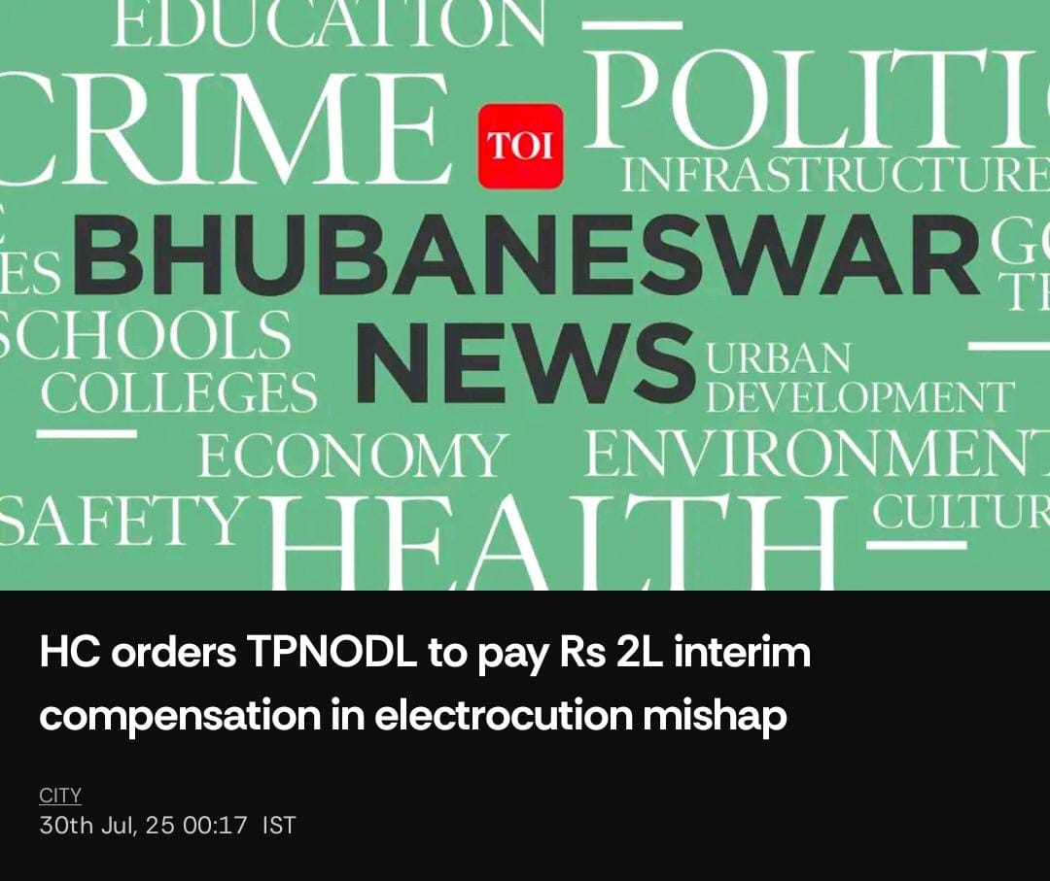
LIVE LAW
